YOLO(You only Look Once)

YOLO is almost standard way of detecting object in field of Computer Vision.

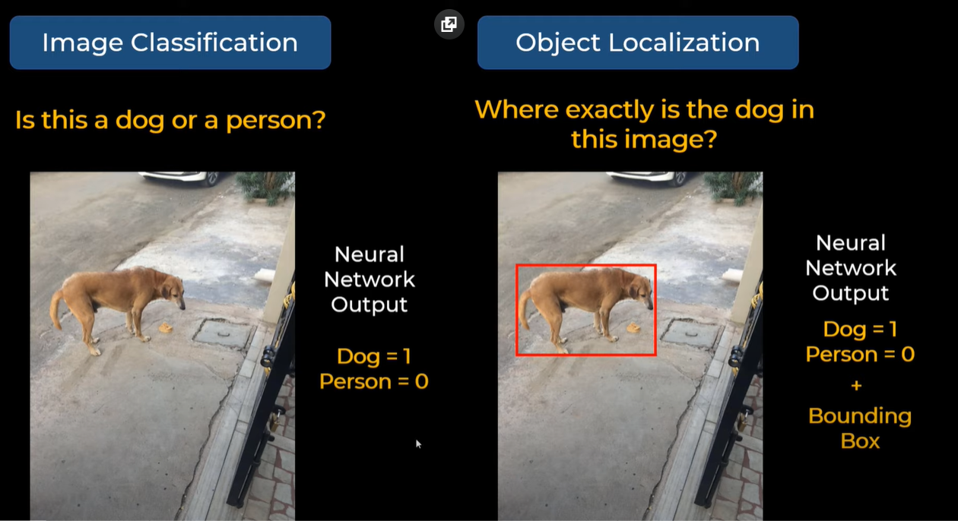

# How it works?

# 

In object localization we are not only telling which class it is but we are also showing the bounding box(i.e. position of the object within the image).

Here image after processing through a CNN generates an Vector-

Pc - probability of the class

Bx & By – coordinates of centre of the bounding box

Bw & Bh - Width and height of bounding box

C1 & C2 – are two different classes

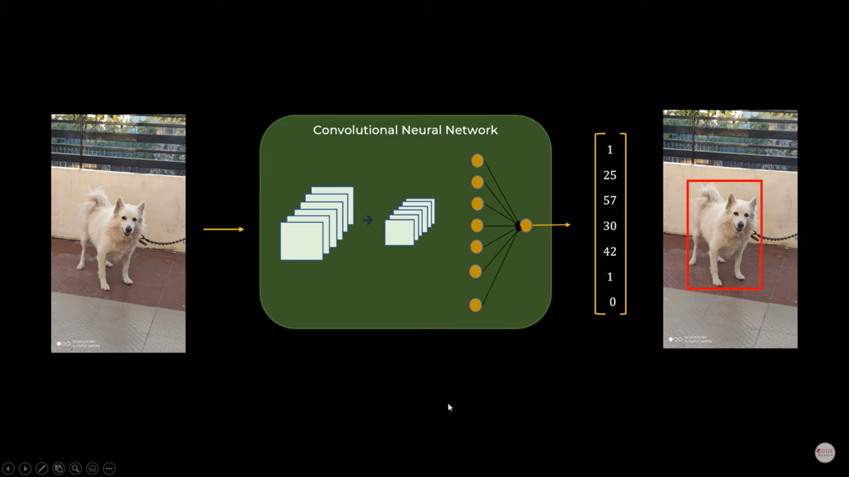

This only work for single object.

# For Multiple Objects-

In this case YOLO Algorithm will divide the image into grid form(here 4 by 4) & for each grid there will be a vector generated(16 per vector in training image).

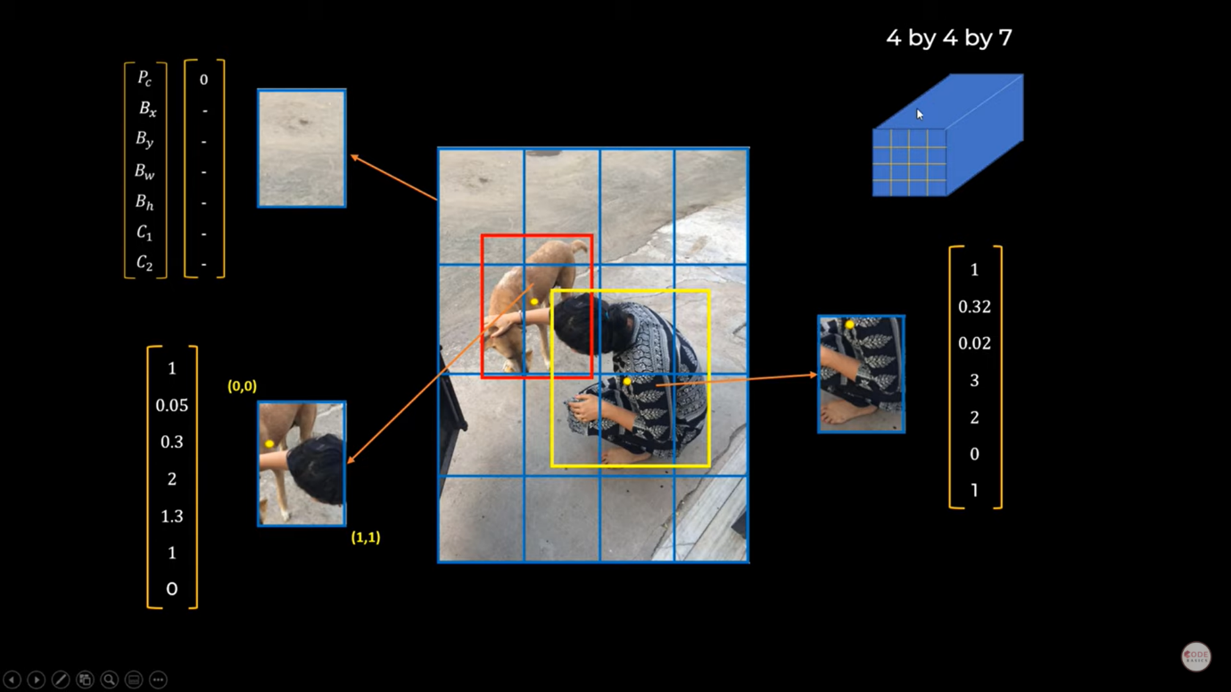

After training the data set it is capable of prediction.

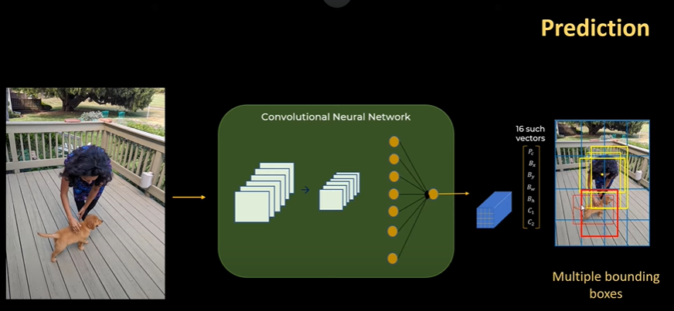

# But how to tackle multiple Bounding Box?

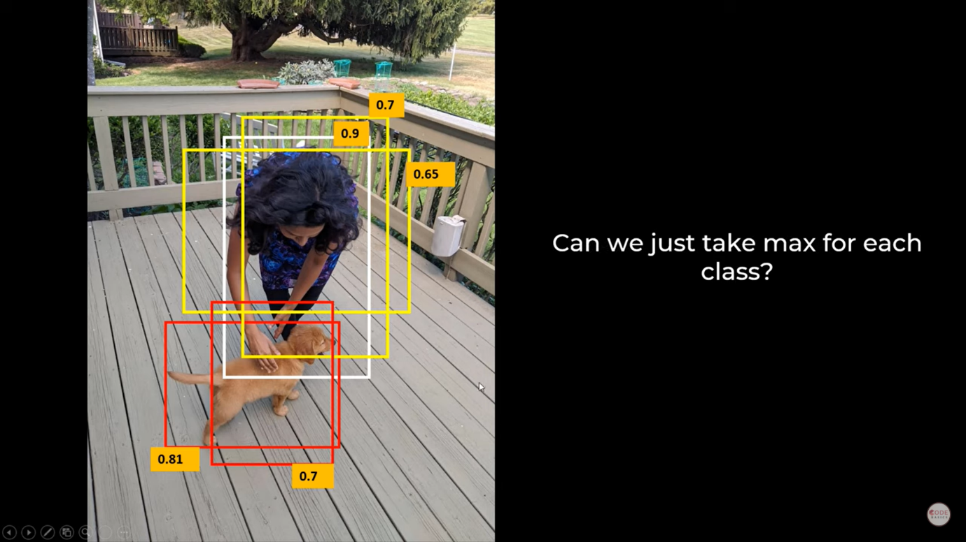

# We use IOU(Intersection Over Union)

IOU = intersect area/union area

correct if IOU>=0.5

higher the iou more accurate the prediction is.

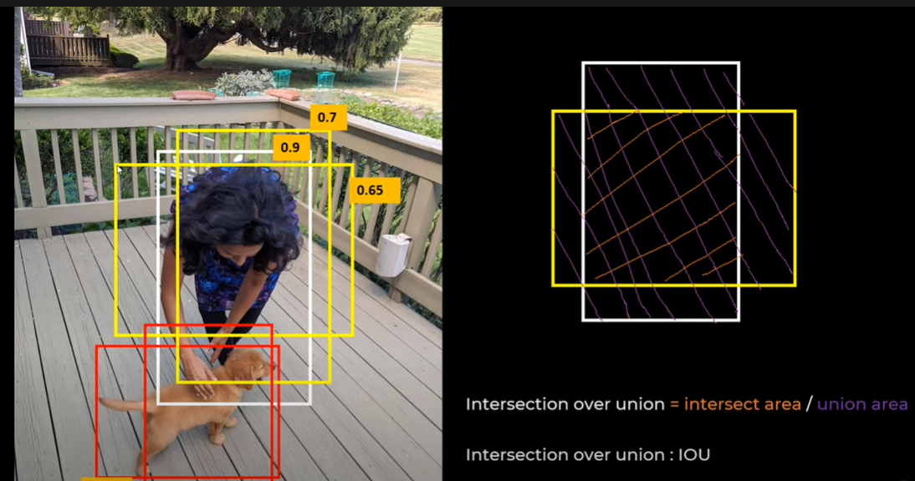

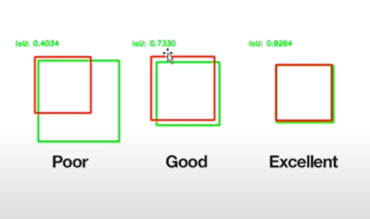

# NON MAX Suppression

It is a common algorithm used for cleaning up when multiple boxes are predicted for the same object.

It will clean up our results:

1.Discard all boxes with IOU probability less or equal to 0.6.  
2.Pick the box with the largest probability output as a prediction.  
3.Discard any remaining box with IOU greater than or equal to 0.5.

